|  |  |
| --- | --- |
| Course Name | ITD 1253 – Object Oriented Programming with C# |
| Instructor | Mark L. Pranger |
| Student Name | Sharyl Hammer |
| Due date | November 30, 2016 |
| Grade |  |
| Grading Comments |  |
|  |  |

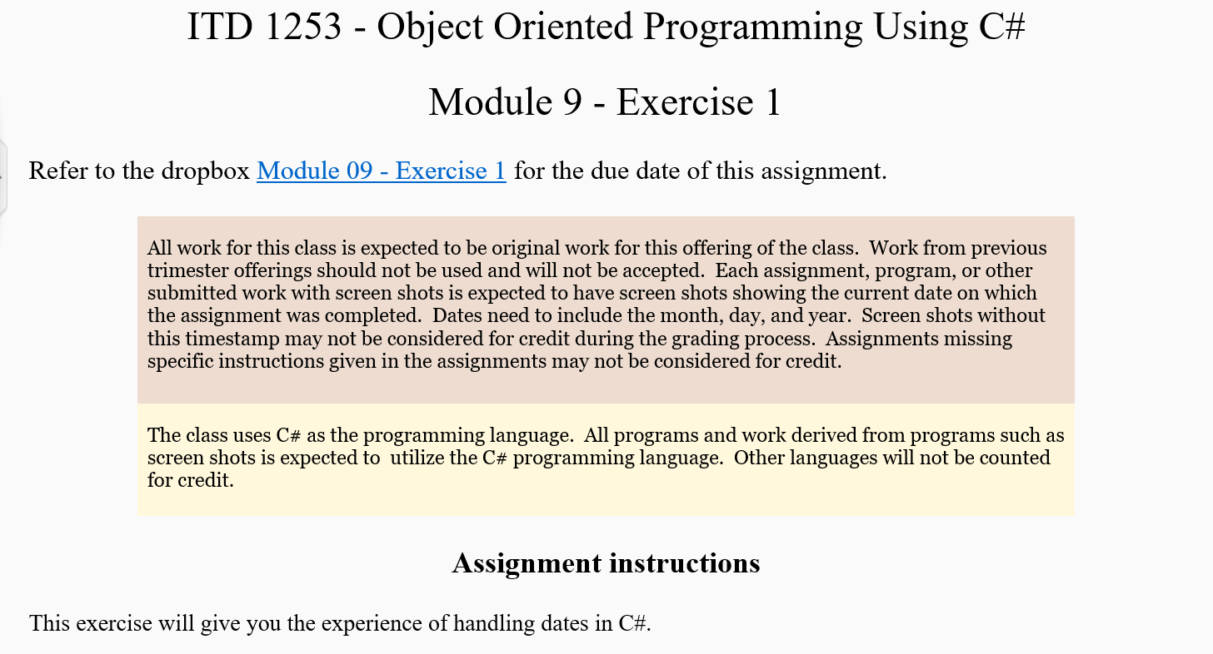

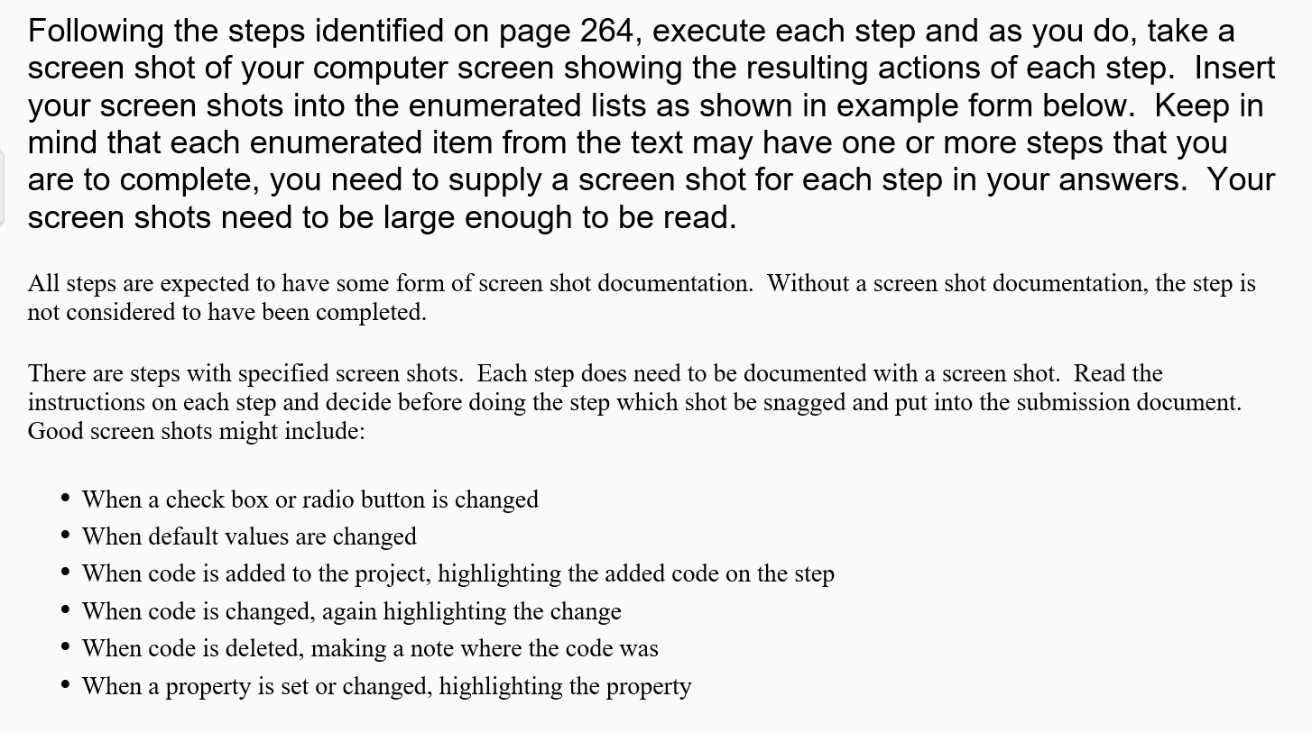

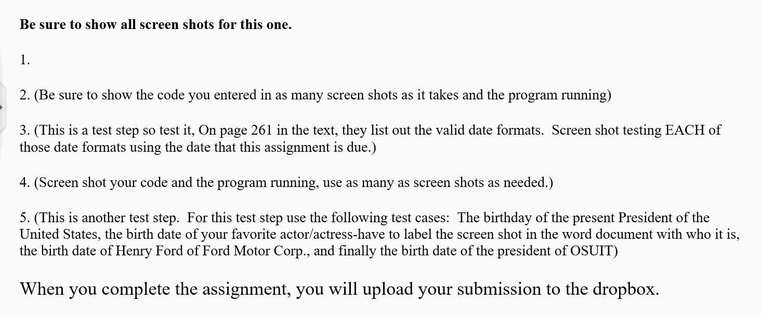



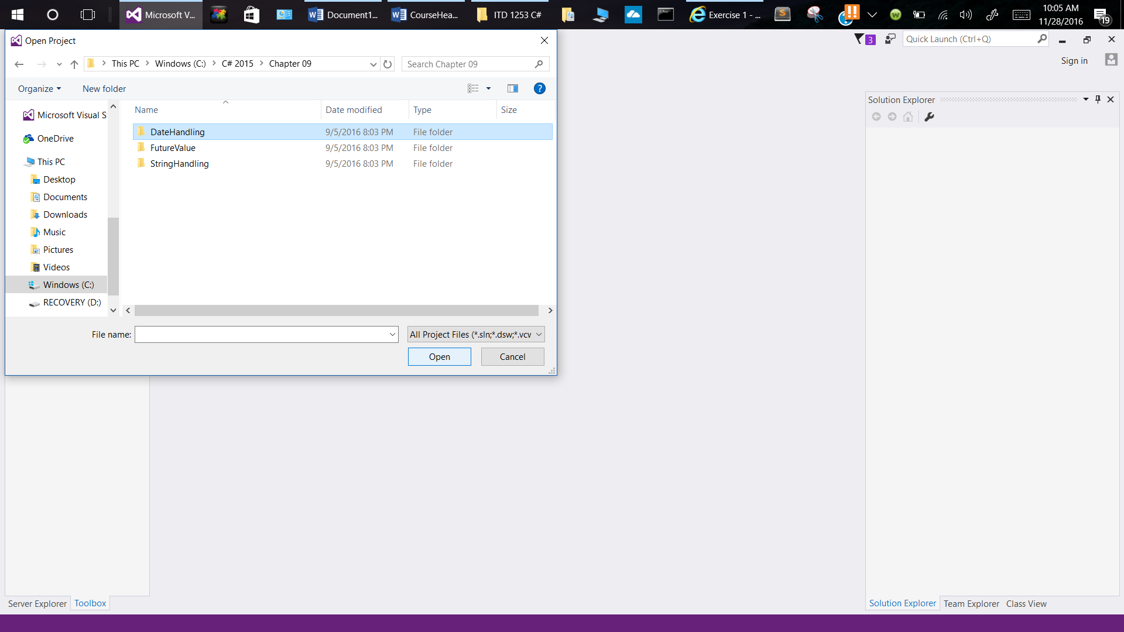

1. Opening DateHandling Application

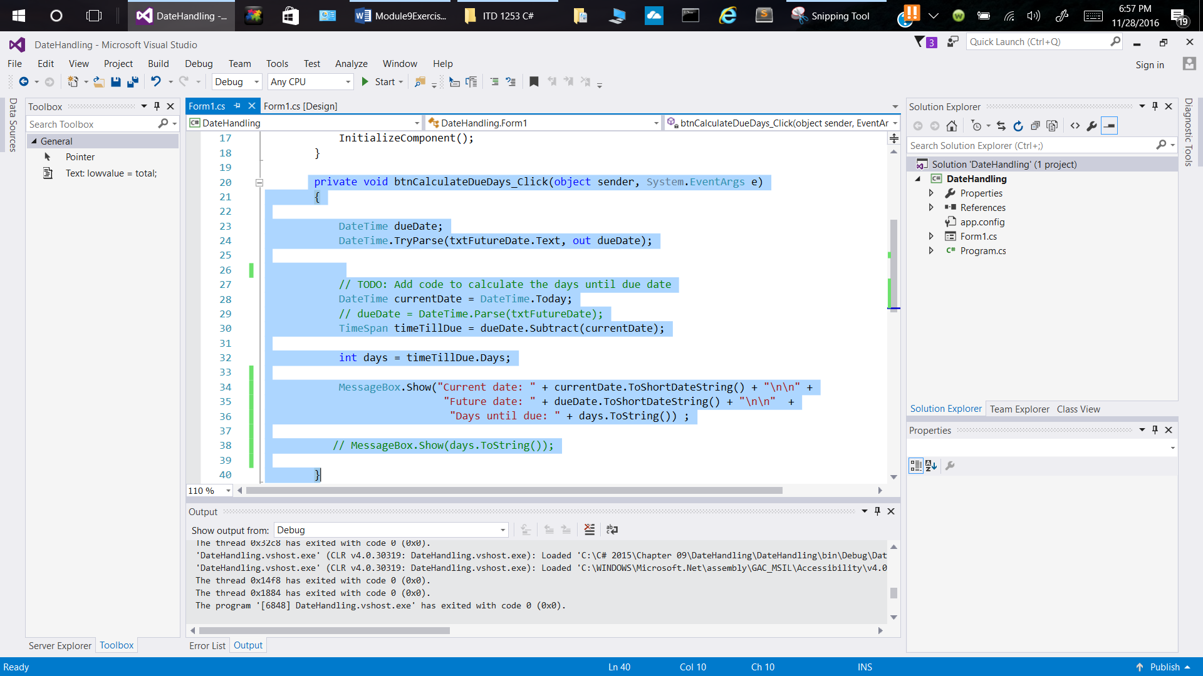

1. Code for btnCalculateDueDays

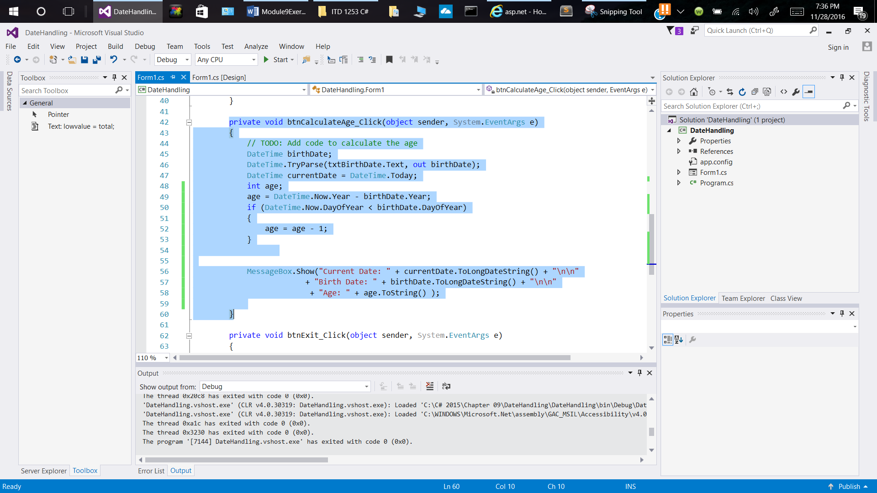

1. Code for btnCalculateAge_Click

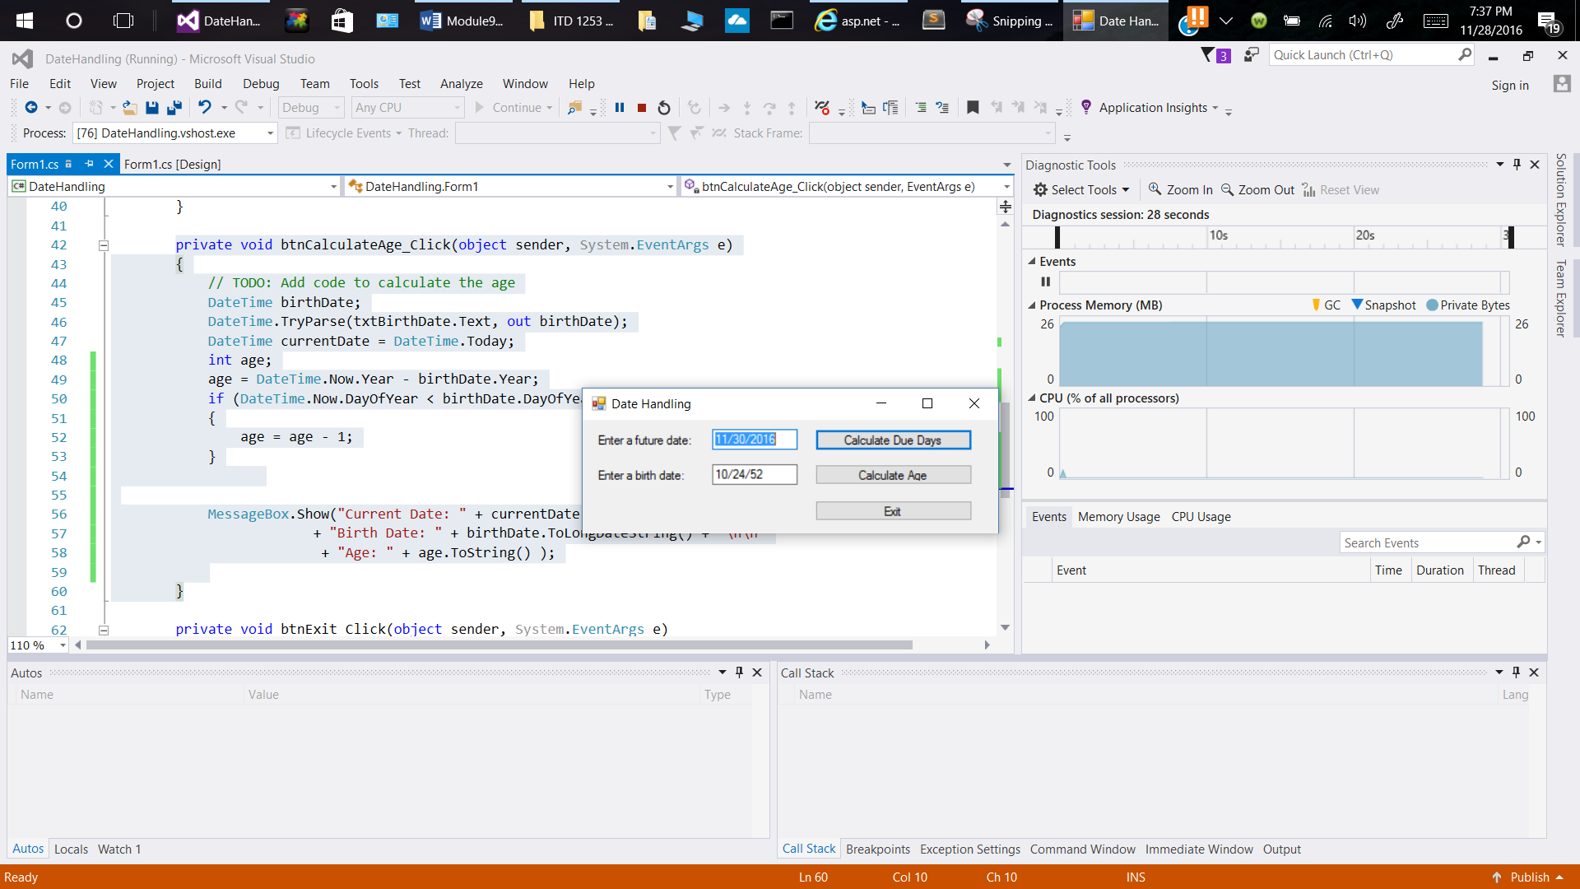

1. Running Program

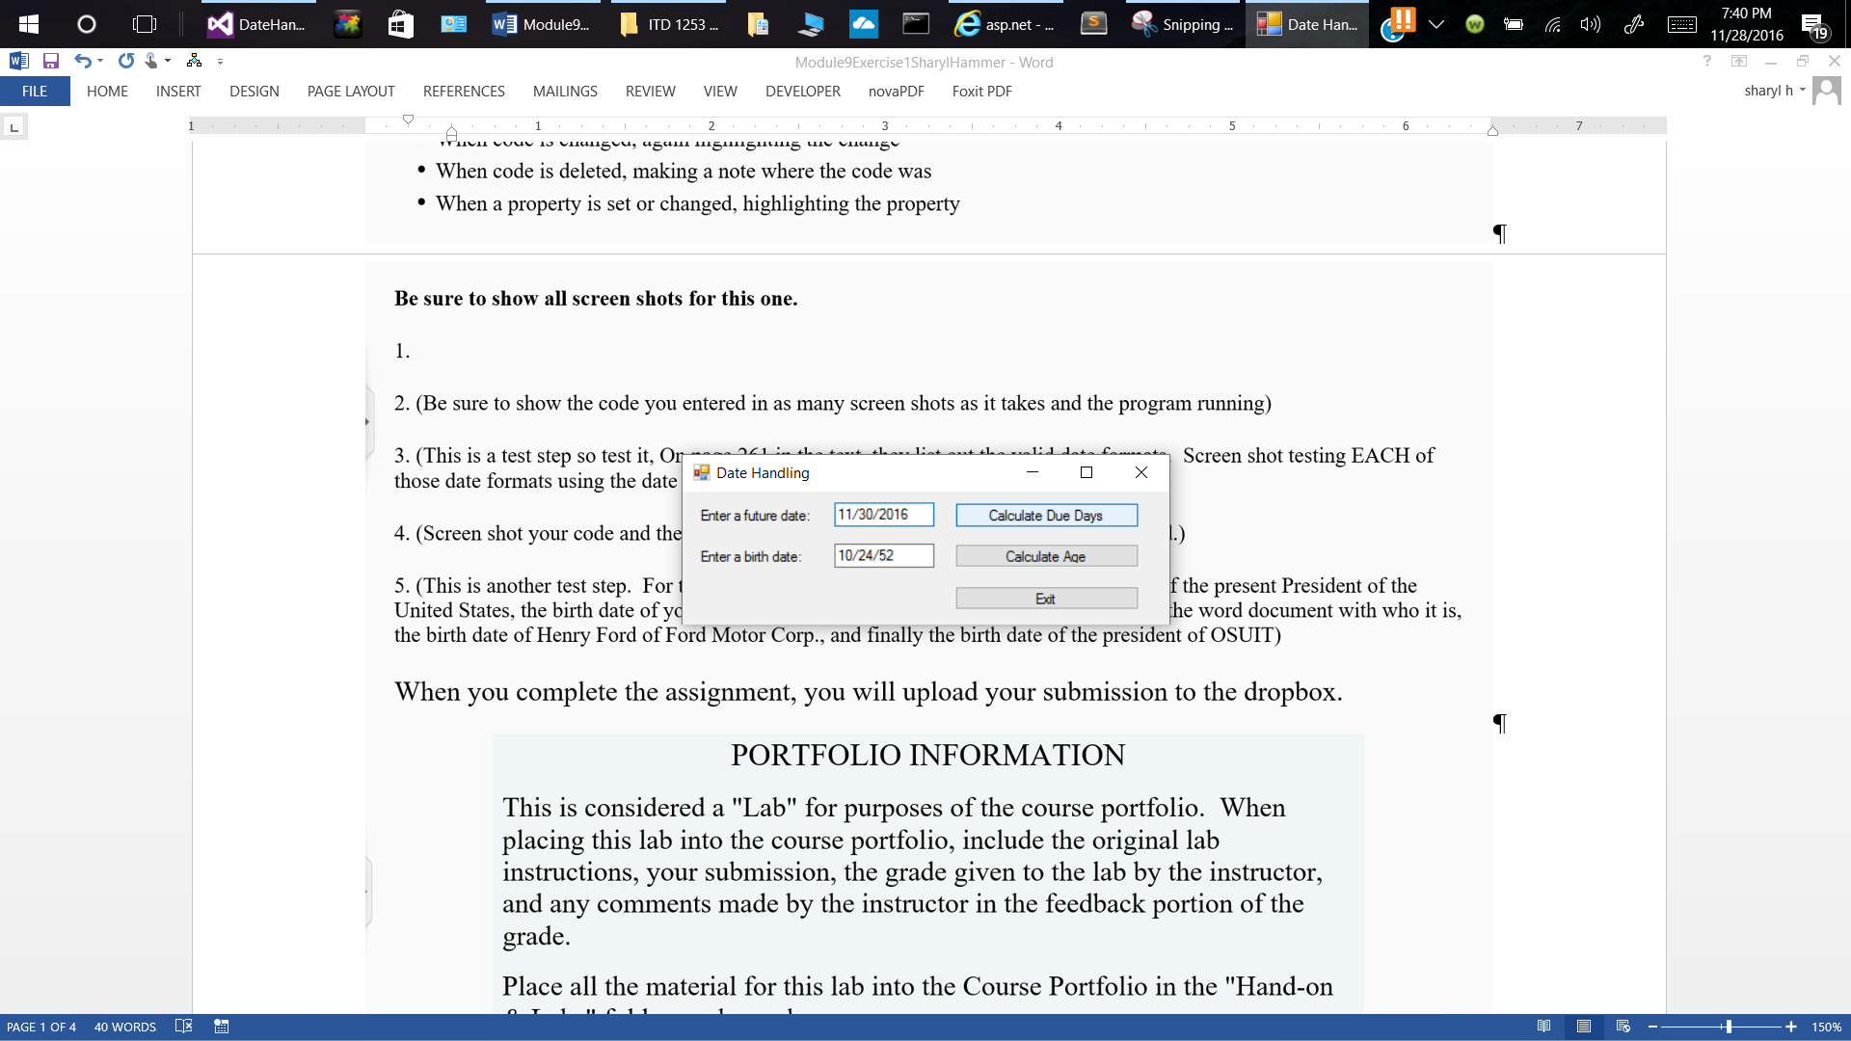

1. Testing Valid Date Formats

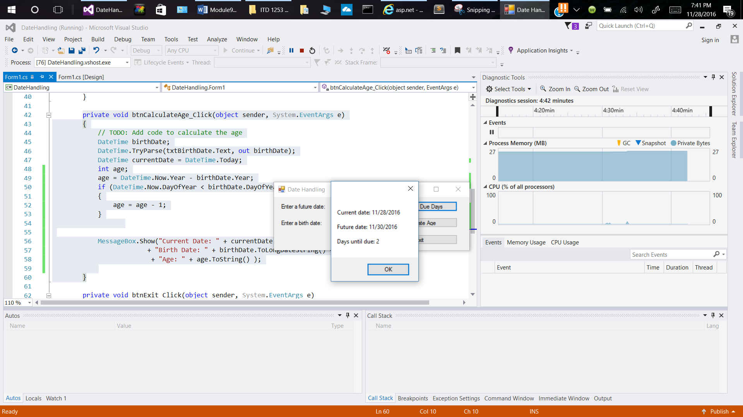

Testing Results: 11/30/2016 format

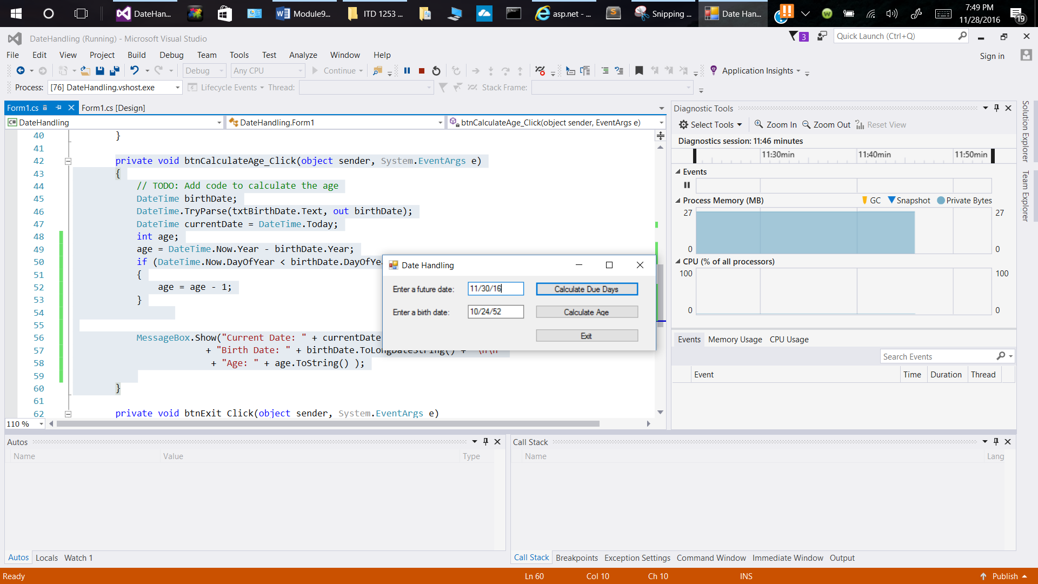

Testing Format 11/30/16

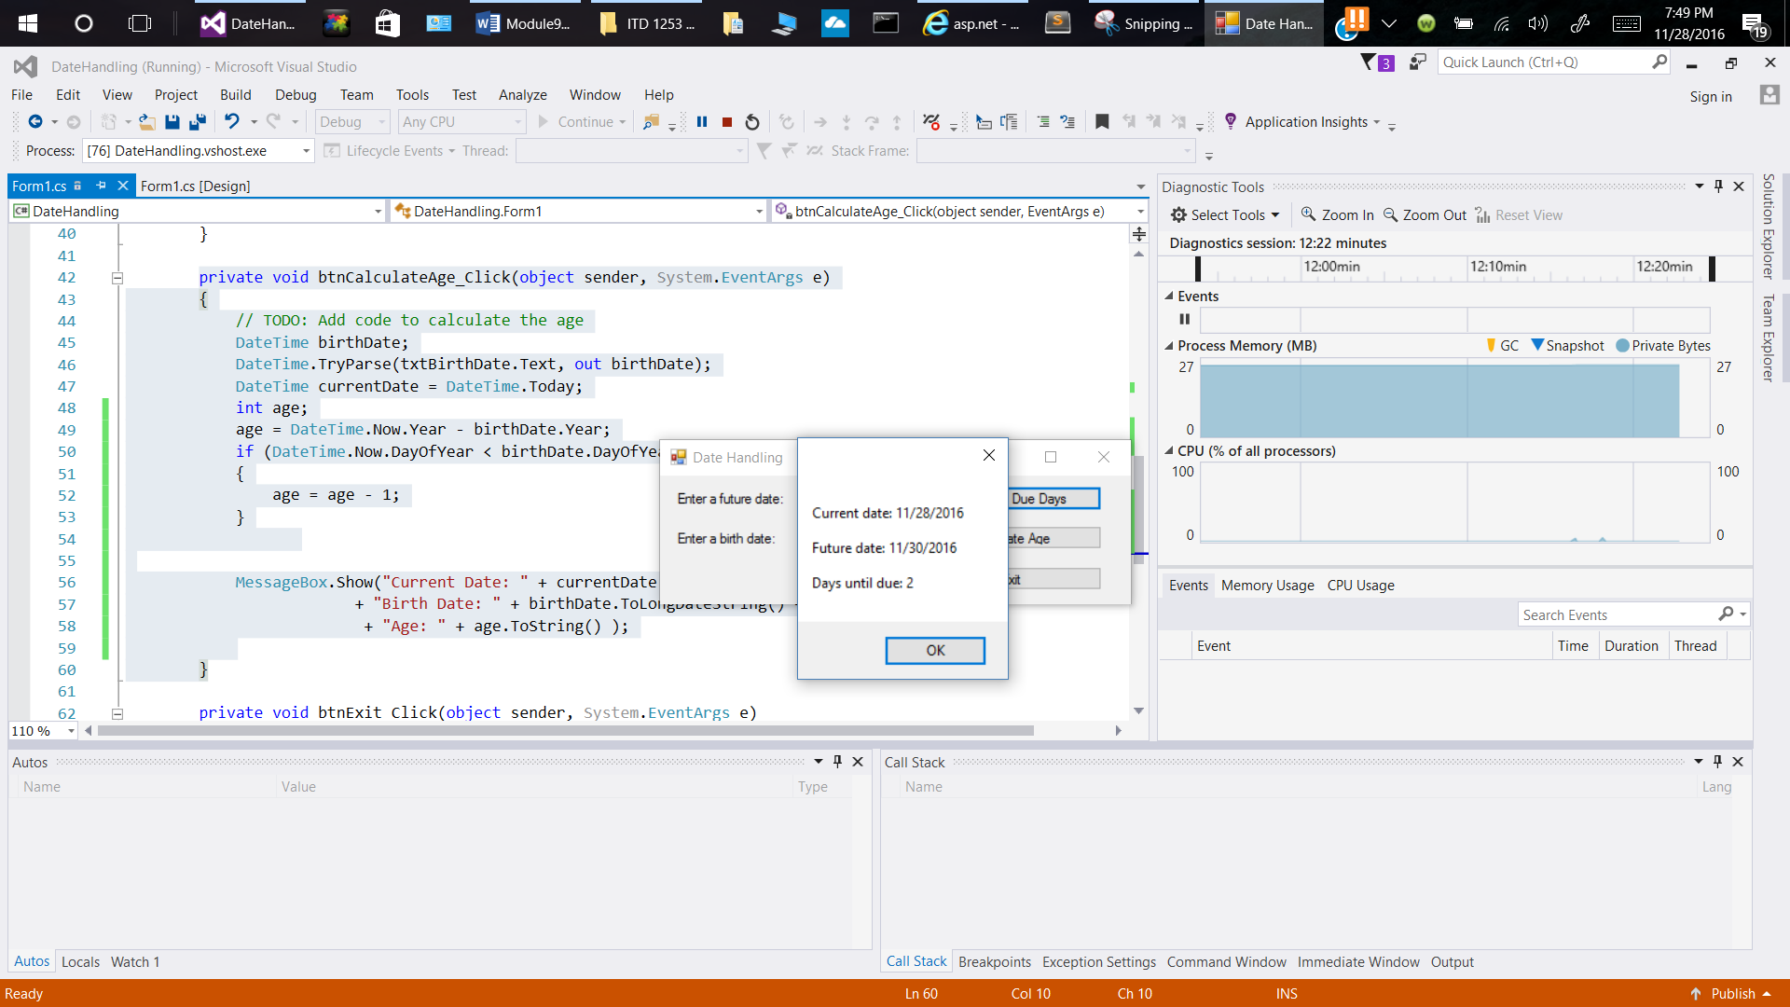

Results of Test for 11/30/16 format

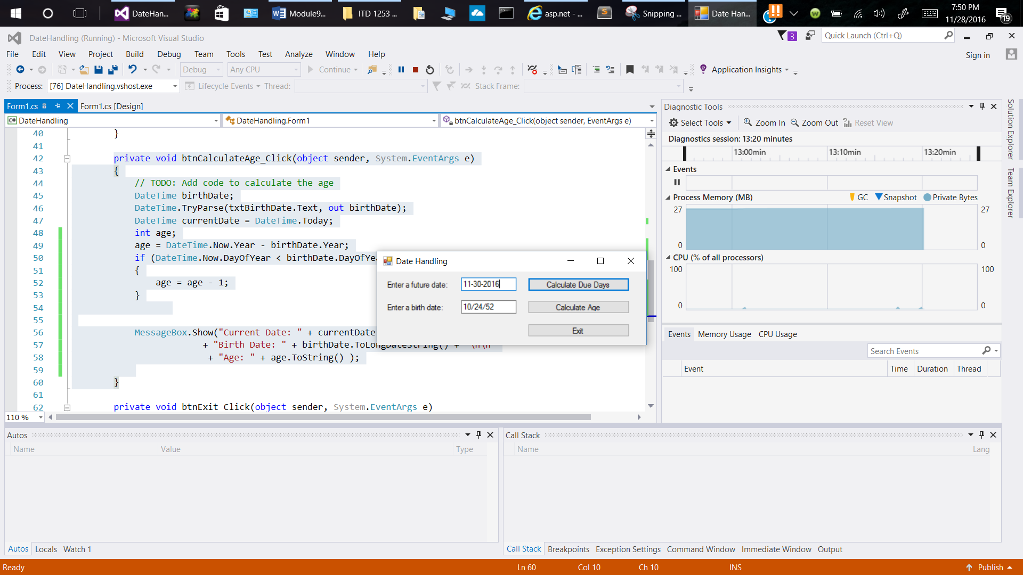

Testing Date Format 11-30-2016

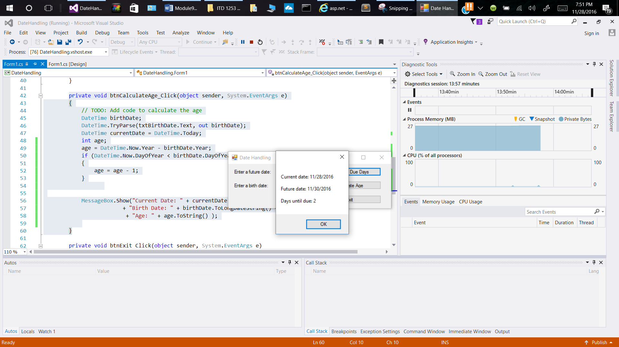

Results for Test 11-30-2016

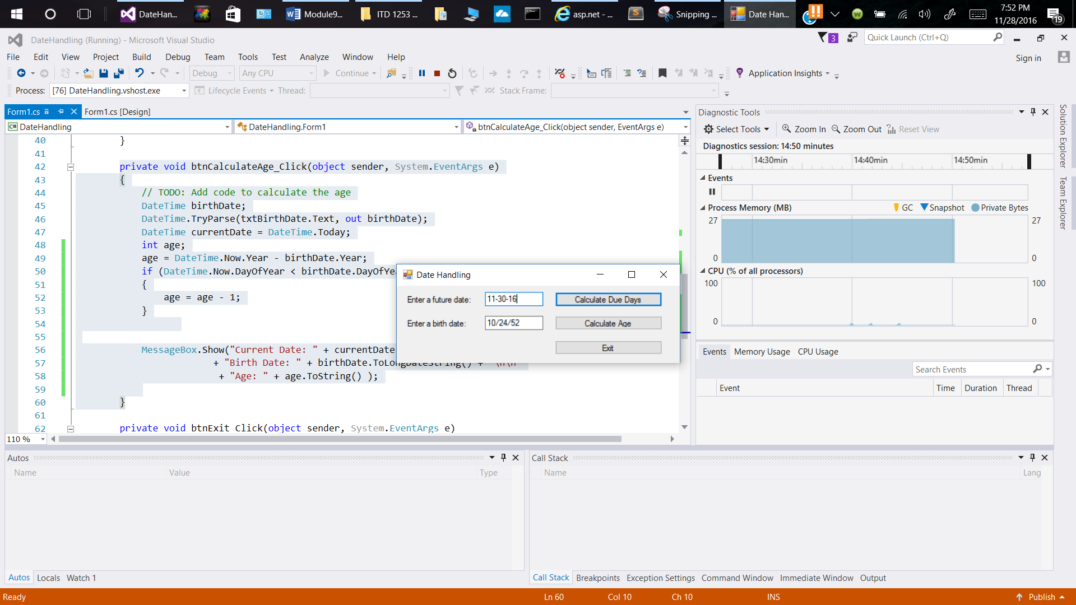

Testing Date format: 11-30-16

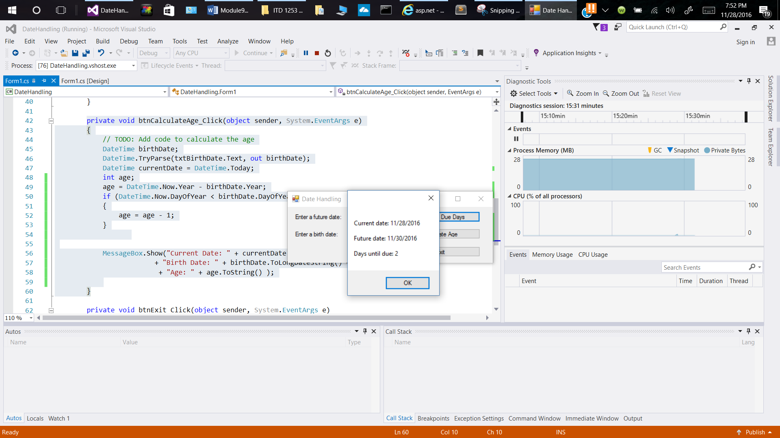

Results of testing date format 11-30-16

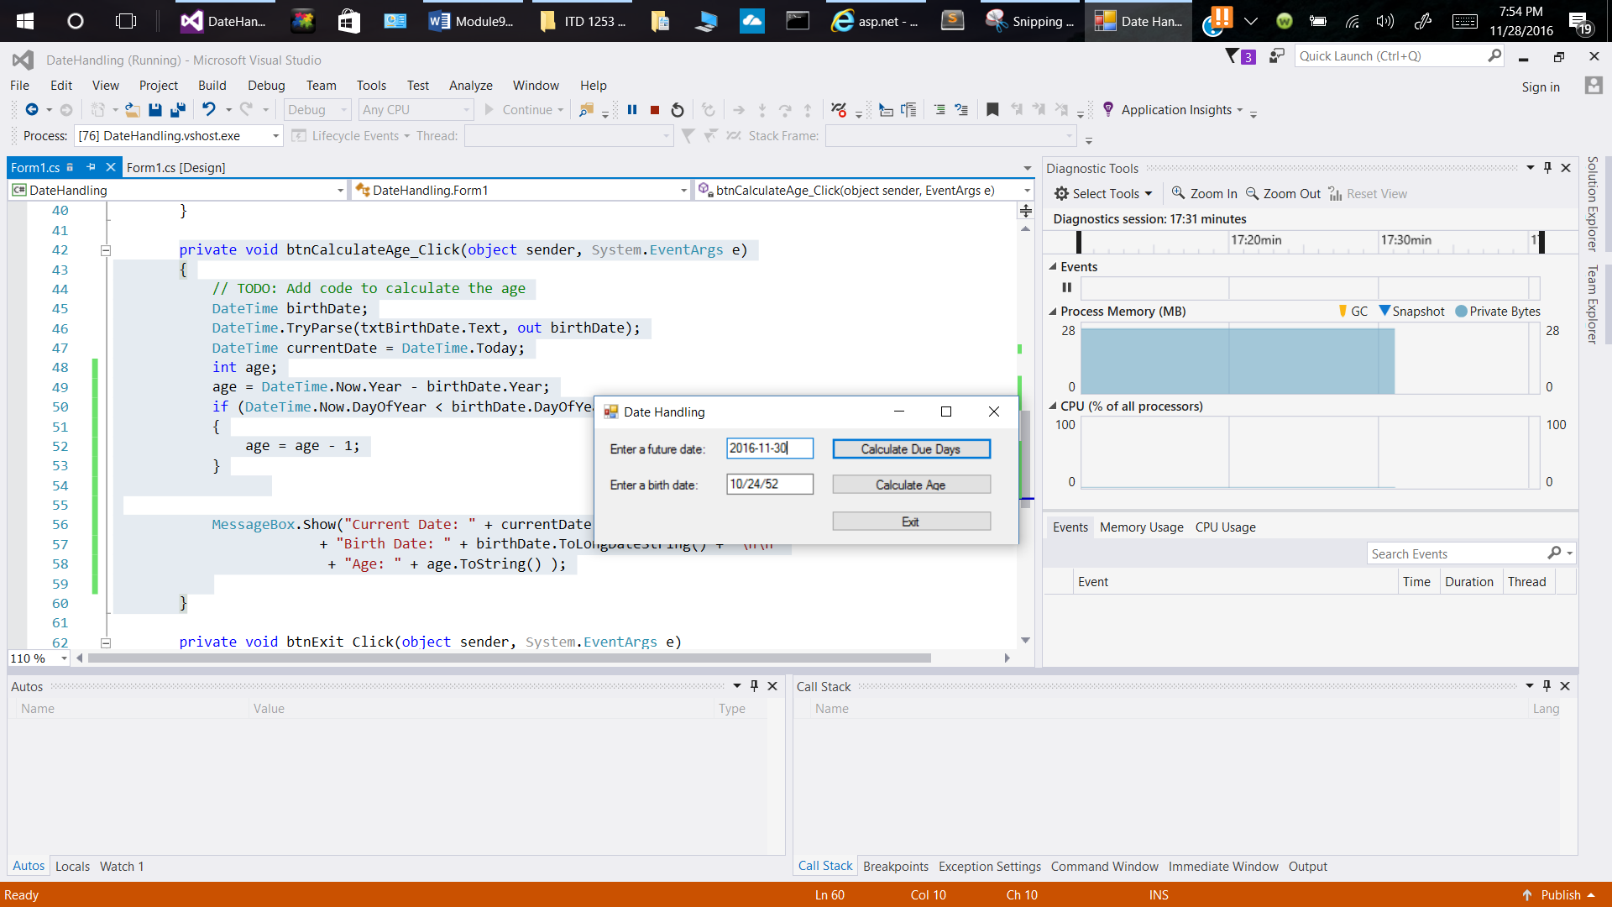

Testing Date format 2016-11-30

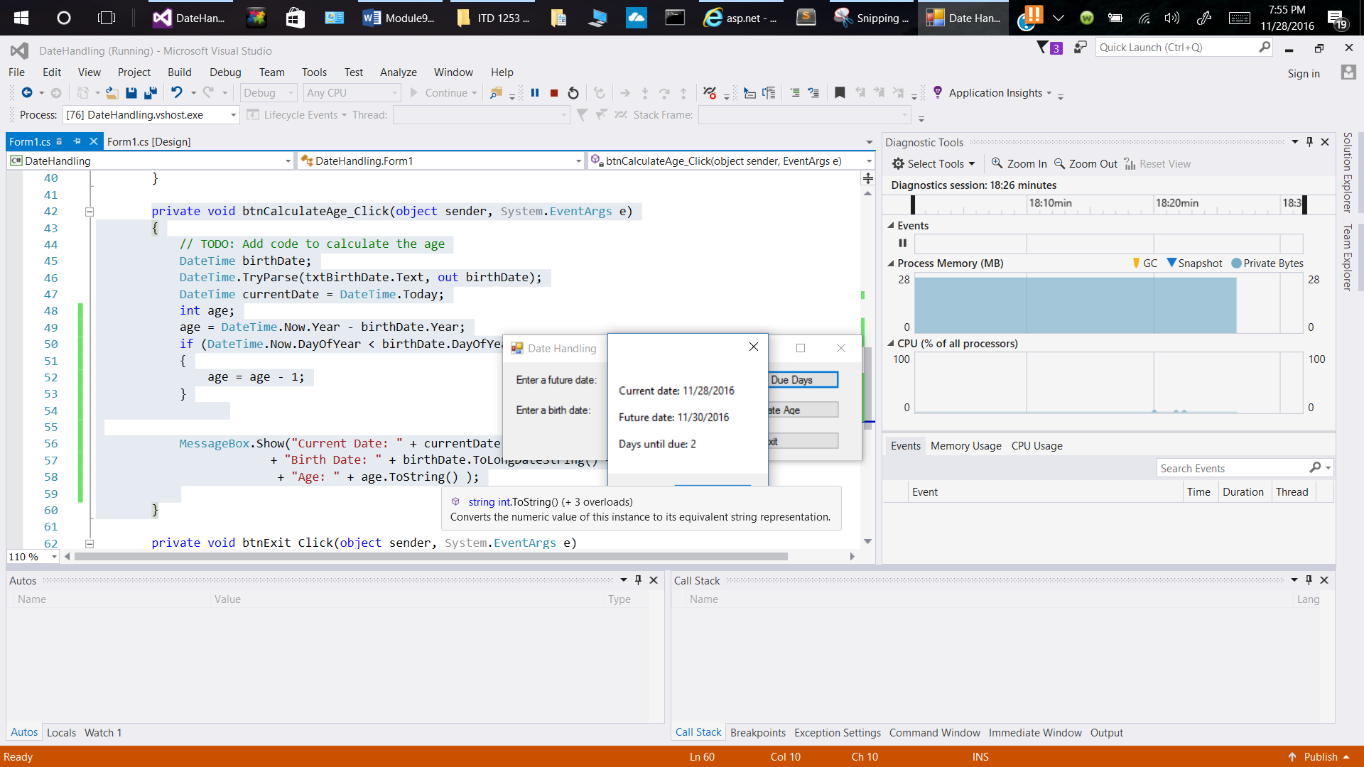

Testing Results of date format 2016-11-30

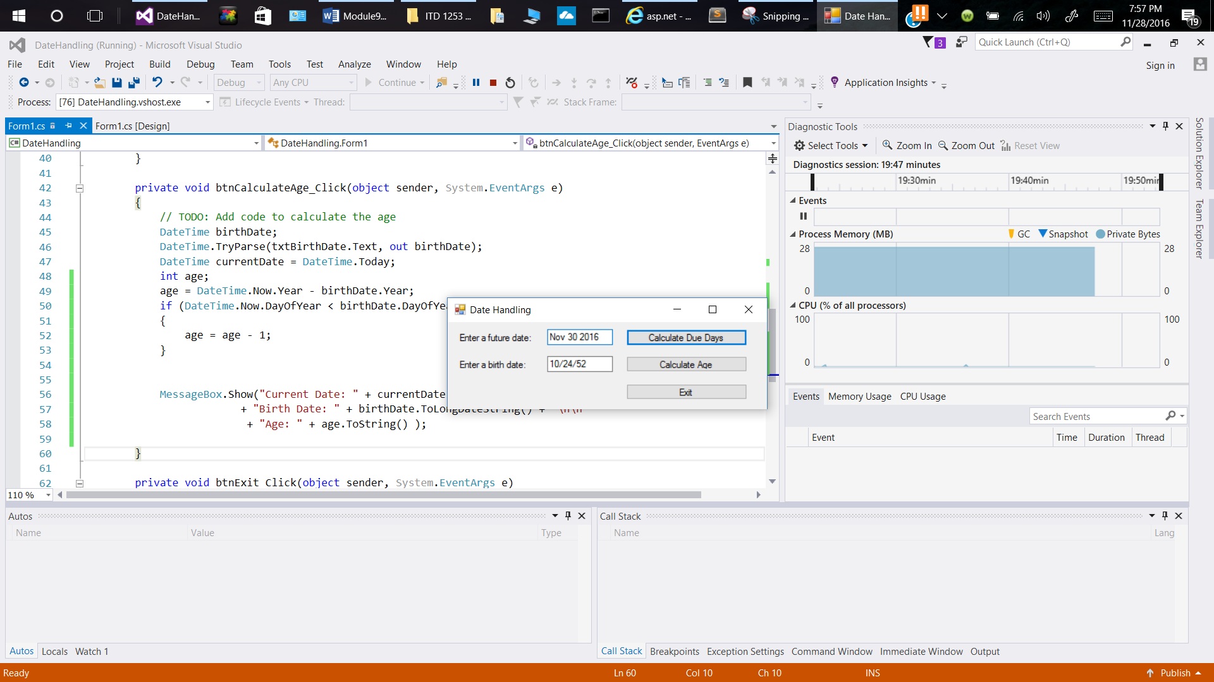

Testing date format Nov 30 2016

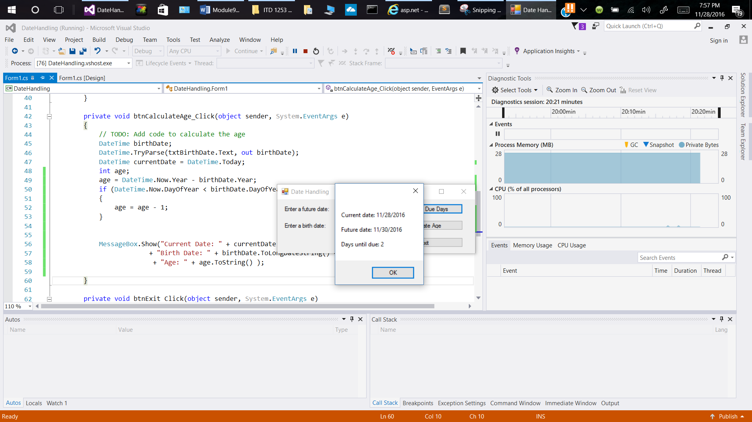

Testing Results of date format Nov 30 2016

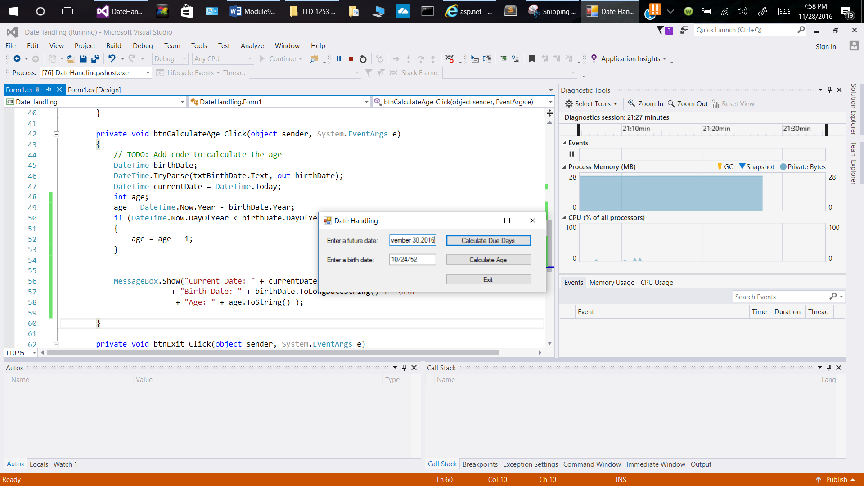

Testing date format November 30, 2016

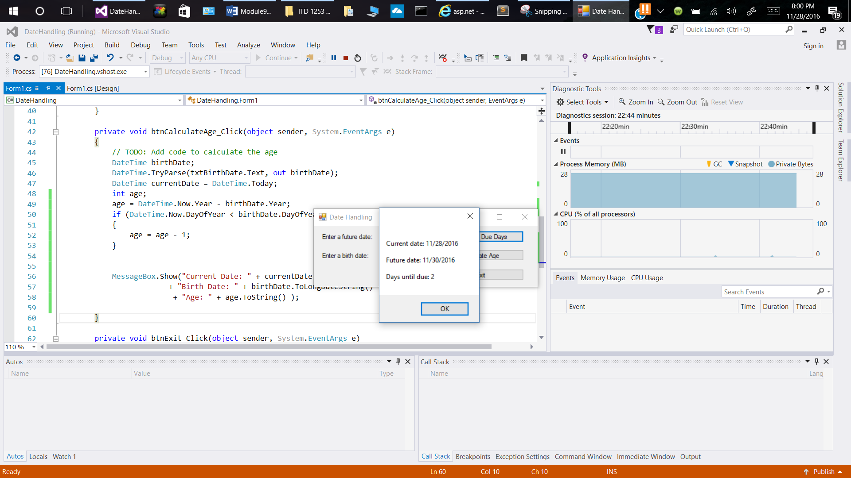

Testing Results of date format November 30, 2016

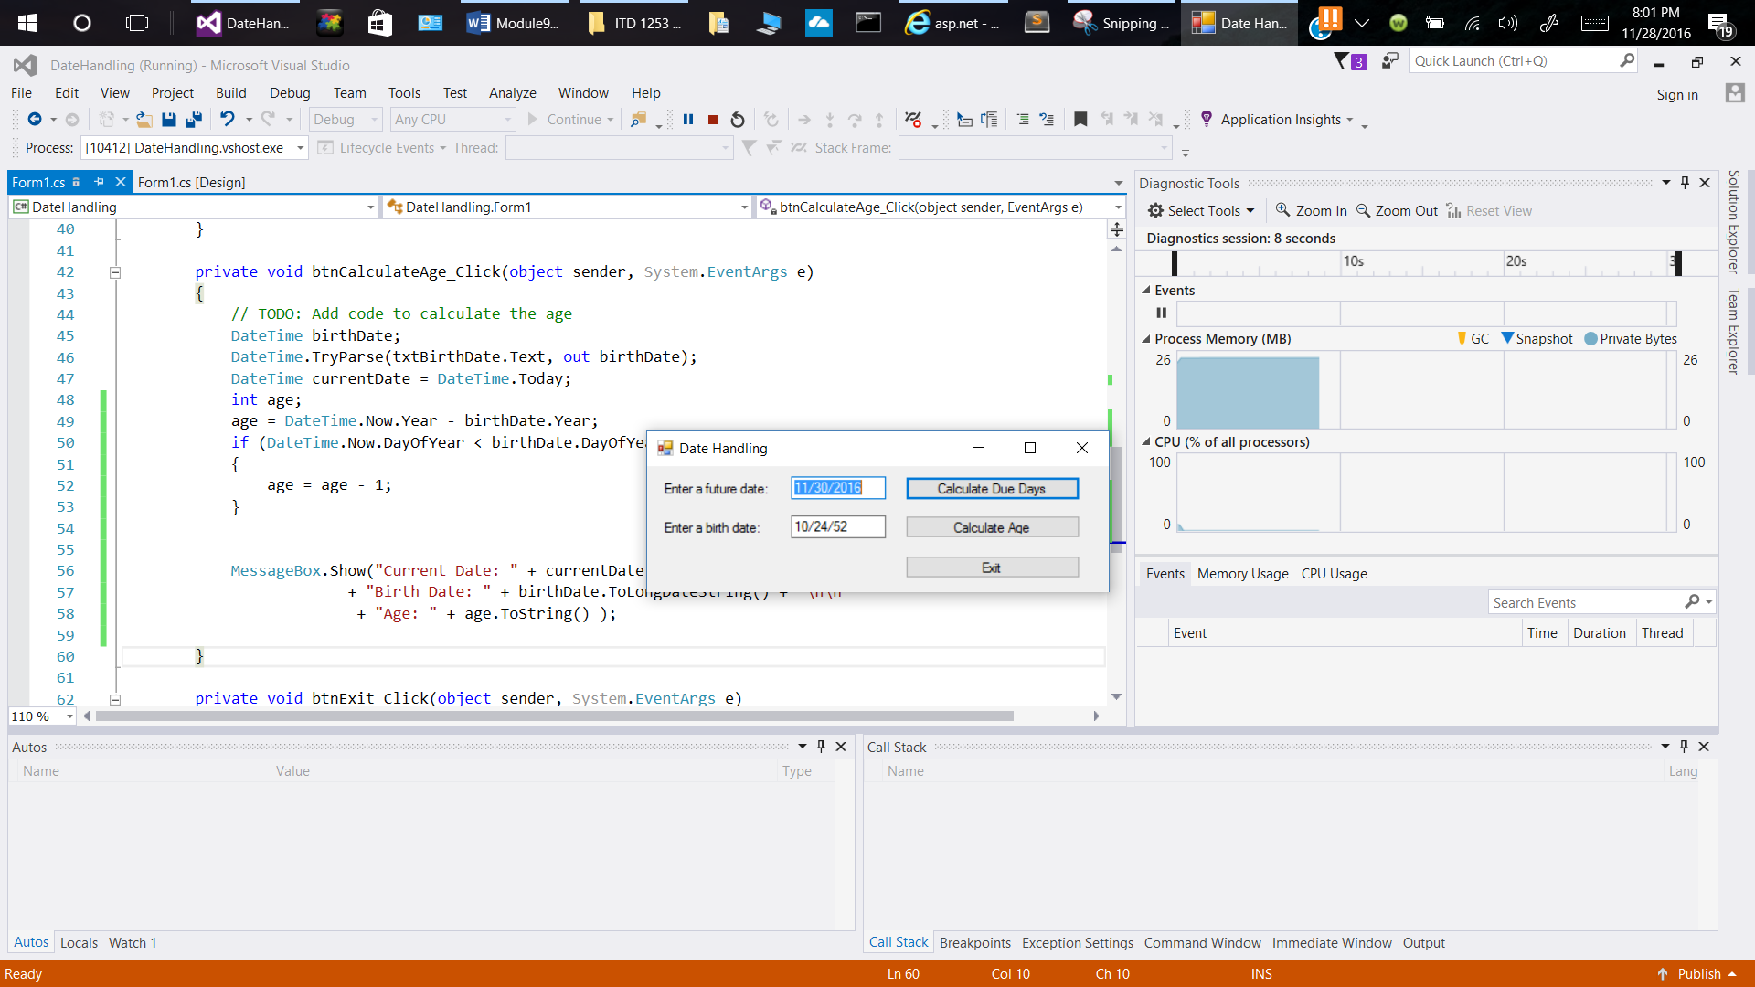

1. Running the Program

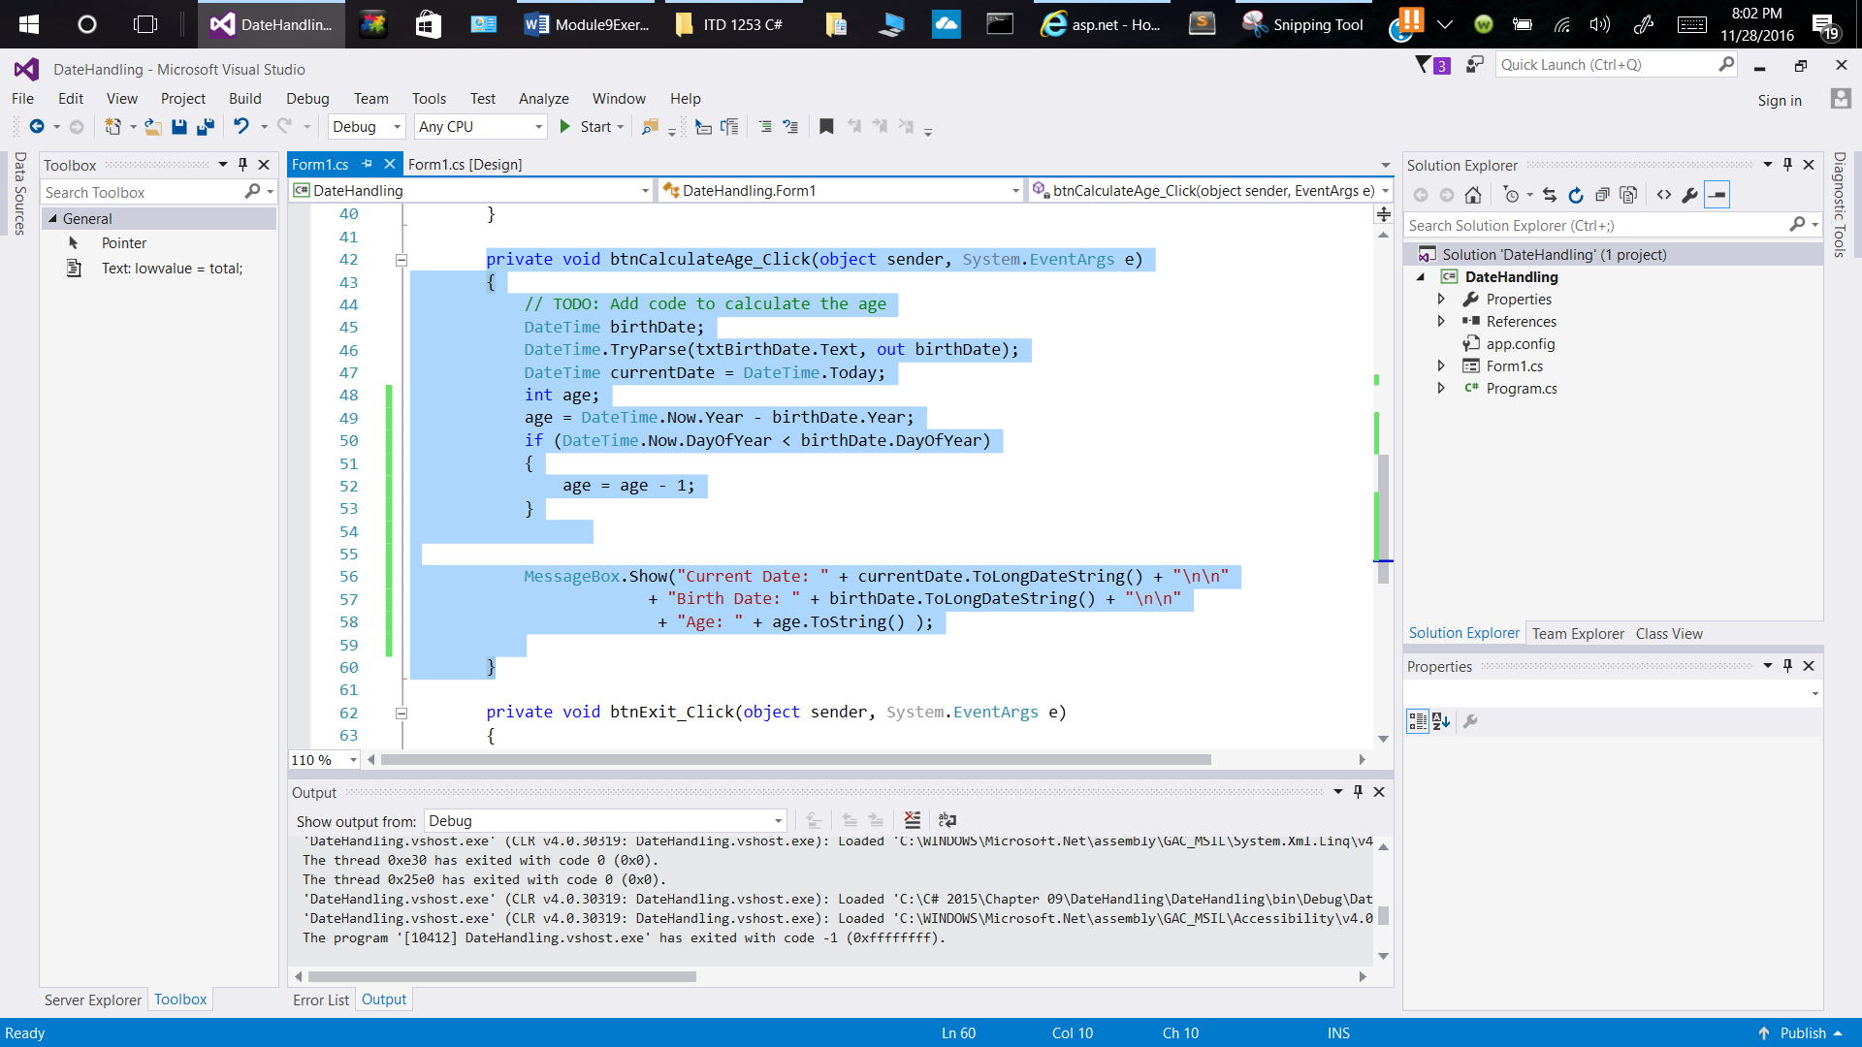

Code of the btnCalculateAge_Click

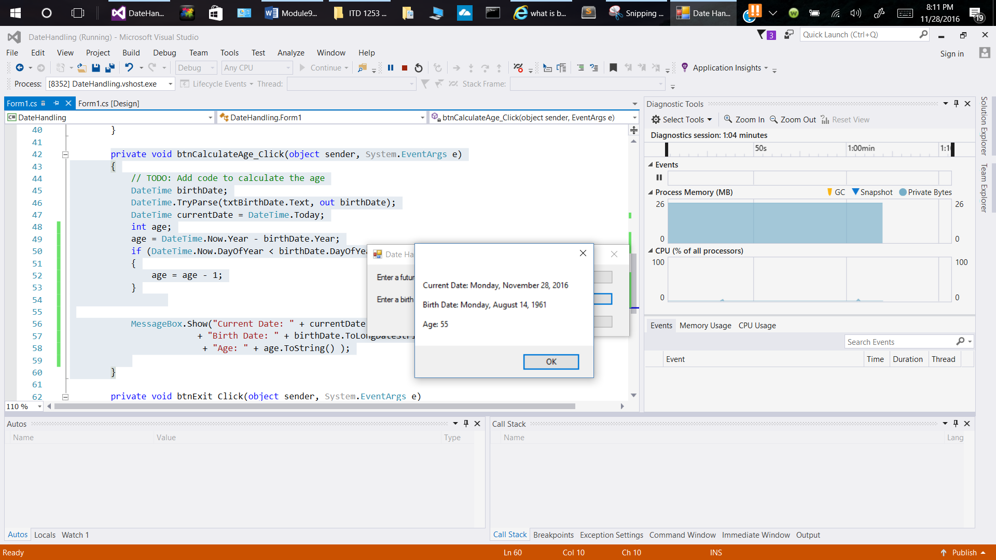

Barack Obama birthdate and age 55

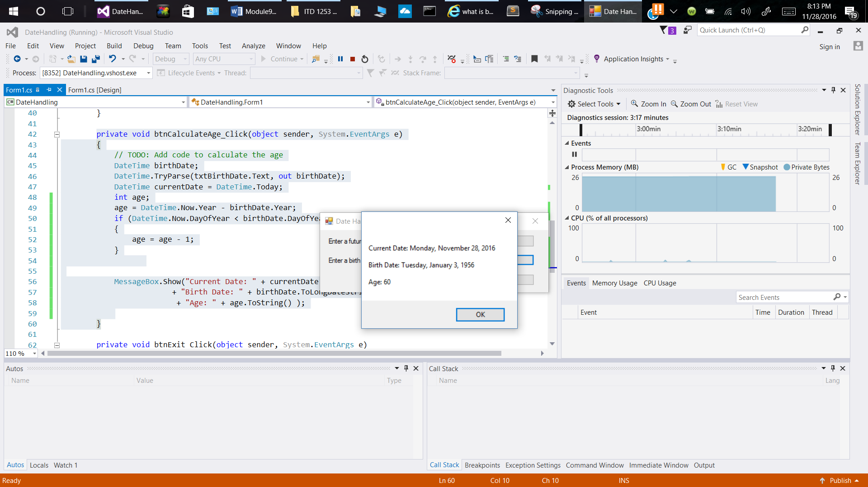

Mel Gibson’s birthdate and age

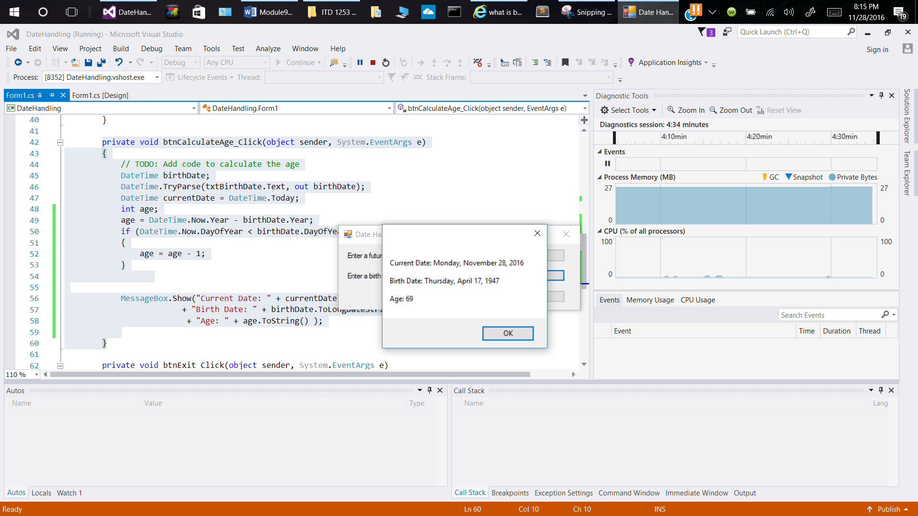

Henry Ford birthdate and age

President of OSU IT can’t find his birth date age 55.